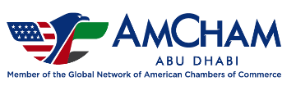
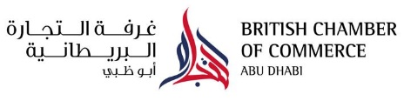
Battle of the Abu Dhabi Business Community Golf Day
Player Registration Form
Friday 7th October 2022 Saadiyat Beach Golf Club, Abu Dhabi

Player Name | Company Name | Mobile Number | Email Address | Handicap | Shirt Size
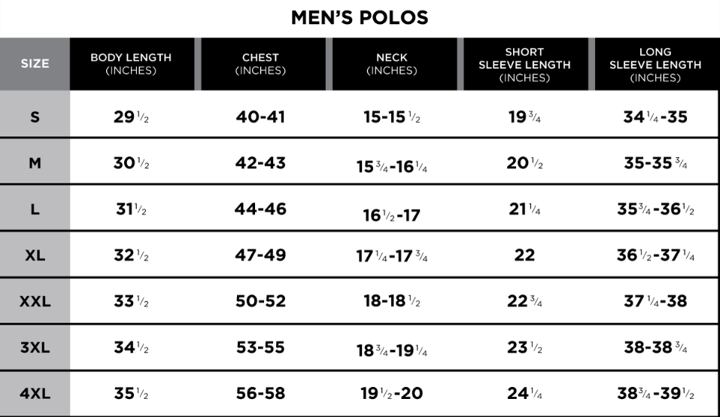
Partnership Opportunities:
Would you like to sponsor a hole?
Would you like to provide a raffle prize?
Contact events@bccad.ae to discuss opportunities for your company.
Deadline:
Payment must be complete by 28th September to confirm participation. BCC AD is not responsible for disappointment caused if player slots fill before deadline.
Contact events@bccad.ae or 02-4457234.

With thanks to Title Event Sponsor:

